**Ideation Phase**

**Define the Problem Statements**

|  |  |
| --- | --- |
| Date | 27 JUNE 2025 |
| Team ID | LTVIP2025TMID59834 |
| Project Name | TrafficTelligence: Advanced Traffic Volume Estimation with Machine Learning |
| Maximum Marks | 2 Marks |

**Customer Problem Statement Template:**

To overcome the problem of traffic congestion, the traffic prediction using machine learning which contains regression model and libraries like pandas, os, numpy, matplotlib.pyplot are used to predict the traffic. This has to be implemented so that the traffic congestion is controlled and can be accessed easily. Users can collect the traffic information of the traffic flow and can also check the congestion flow from the start of the day till the end of the day with the time span of one hour data. In this way, Users can know the weather conditions of the roads that they would probably opt to take. This also tells the accuracy of the traffic by comparing their mean square errors of the past year’s data and the recent year’s data. Users can also know how many vehicles are traveling on average by the traffic prediction

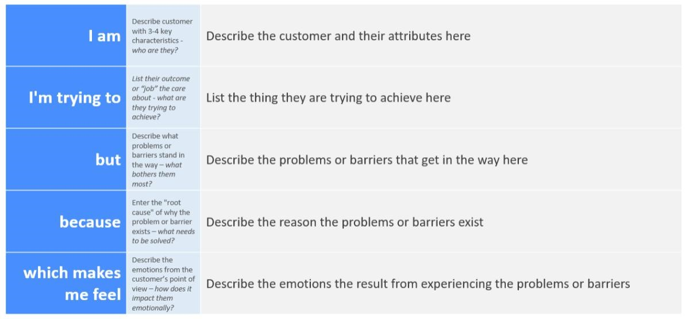

Reference: <https://miro.com/templates/customer-problem-statement/>

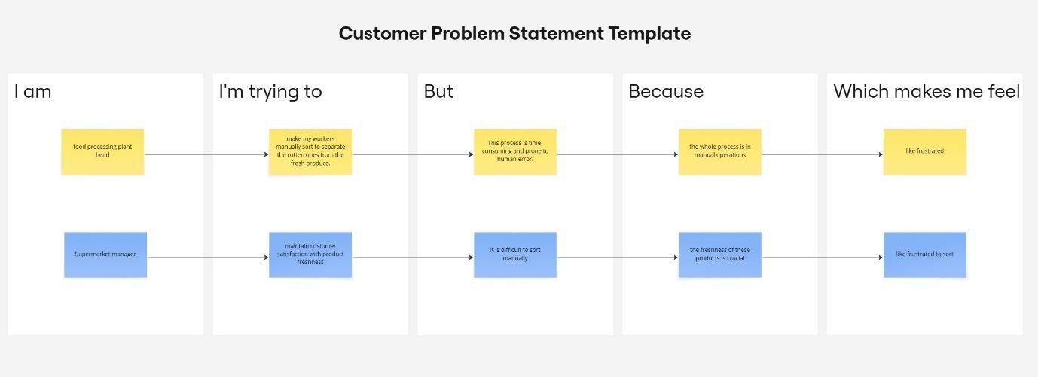

|  |  |  |  |  |  |
| --- | --- | --- | --- | --- | --- |
| **Problem**  **Statement (PS)** | **I am**  **(Customer)** | **I’m trying to** | **But** | **Because** | **Which makes me feel** |
| PS-1 | a world traveller. | Find the traffic less roads to travel easily to my destination. | It is difficult to know the traffic on the roads. | the whole process is in manual operations | like frustrated |